

Lab-2

JAVA PROGRAMMING



Lamia Alam Shova

Student ID: 301259598

**Assignment -2**

**Lab2Exercise1:**

Main class :

package lab2exercise1;  
  
public class Main {  
 public static void main(String[] args) {  
 Test quiz = new Test();  
  
 for (int i = 0; i < quiz.numOfQuestions; i++) {  
 quiz.questionBank(i);  
 }  
  
 quiz.displayResult();  
 }  
}

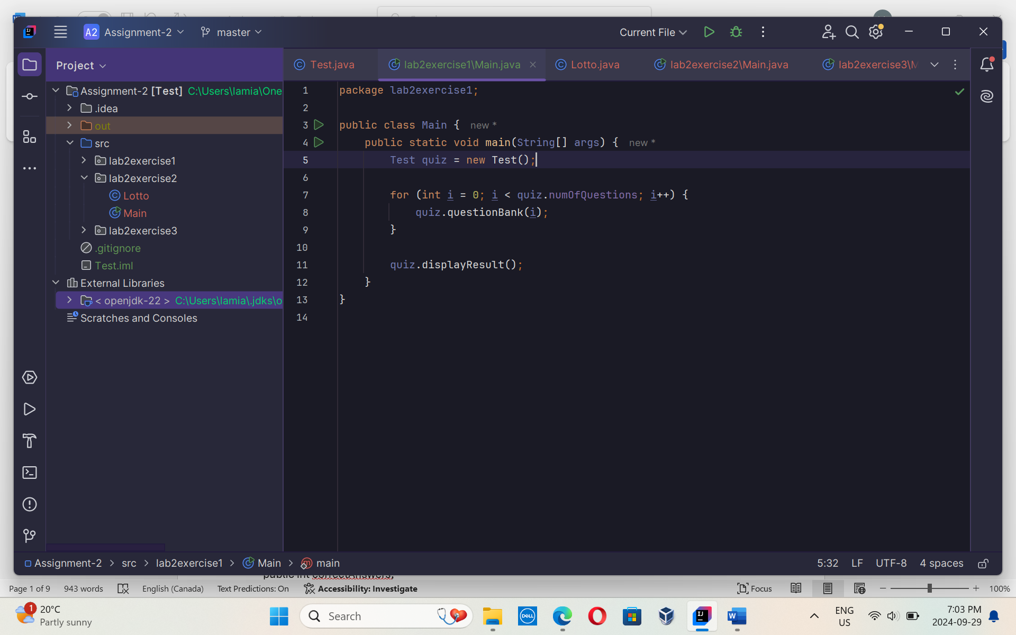

Test class:

package lab2exercise1;  
  
import java.util.Random;  
import javax.swing.JOptionPane;  
  
public class Test {  
  
  
 public int correctAnswers;  
 public int wrongAnswers;  
 public int numOfQuestions = 5;  
  
 //list for questions  
 public void questionBank(int questionBank) {  
 String question;  
 String[] options = new String[4];  
 switch (questionBank + 1) {  
 case 1:  
 question = "Which of the following are not Java keywords?";  
 options[0] = "1. double";  
 options[1] = "2. then";  
 options[2] = "3. instanceof";  
 options[3] = "4. switch";  
 checkAnswer(2, question, options);  
 break;  
 case 2:  
 question = "Which one is a template for creating different objects?";  
 options[0] = "1. Class";  
 options[1] = "2. Array";  
 options[2] = "3. Interface";  
 options[3] = "4. None";  
 checkAnswer(0, question, options);  
 break;  
 case 3:  
 question = "What is the correct syntax for main method?";  
 options[0] = "1. public static void main(String[] args)";  
 options[1] = "2. static public void main(String[] args)";  
 options[2] = "3. void public static main(String args[])";  
 options[3] = "4. public void static main(String[] args)";  
 checkAnswer(0, question, options);  
 break;  
 case 4:  
 question = "What is inheritance in Java?";  
 options[0] = "1. Copying of objects";  
 options[1] = "2. Sharing properties between classes";  
 options[2] = "3. Creating an instance";  
 options[3] = "4. None";  
 checkAnswer(1, question, options);  
 break;  
 case 5:  
 question = "Which keyword is used to access members of the superclass?";  
 options[0] = "1. super";  
 options[1] = "2. extends";  
 options[2] = "3. this";  
 options[3] = "4. None";  
 checkAnswer(0, question, options);  
 break;  
 }  
 }  
 public void checkAnswer(int correctIndex, String question, String[] options) {  
 String input = JOptionPane.*showInputDialog*(null, question + "**\n**" +  
 options[0] + "**\n**" +  
 options[1] + "**\n**" +  
 options[2] + "**\n**" +  
 options[3], "Question", JOptionPane.*QUESTION_MESSAGE*);  
  
 int userAnswer = Integer.*parseInt*(input) - 1; // User input is 1-based index  
 if (userAnswer == correctIndex) {  
 JOptionPane.*showMessageDialog*(null, generateMessage(true));  
 correctAnswers++;  
 } else {  
 JOptionPane.*showMessageDialog*(null, generateMessage(false) + "**\n**Correct answer: " + (correctIndex + 1));  
 wrongAnswers++;  
 }  
 }  
  
 public String generateMessage(boolean isCorrect) {  
 Random random = new Random();  
 String message;  
 switch (random.nextInt(4)) {  
 case 0:  
 message = isCorrect ? "Excellent!" : "No. Please try again.";  
 break;  
 case 1:  
 message = isCorrect ? "Good job!" : "Wrong. Try again.";  
 break;  
 case 2:  
 message = isCorrect ? "Keep up the good work!" : "Don't give up!";  
 break;  
 default:  
 message = isCorrect ? "Nice work!" : "No. Keep trying.";  
 break;  
 }  
 return message;  
 }  
 // Method to display final results  
 public void displayResult() {  
 int percentage = (correctAnswers * 100) / numOfQuestions;  
 JOptionPane.*showMessageDialog*(null, "Correct Answers: " + correctAnswers +  
 "**\n**Wrong Answers: " + wrongAnswers +  
 "**\n**Score: " + percentage + "%");  
 }  
  
}

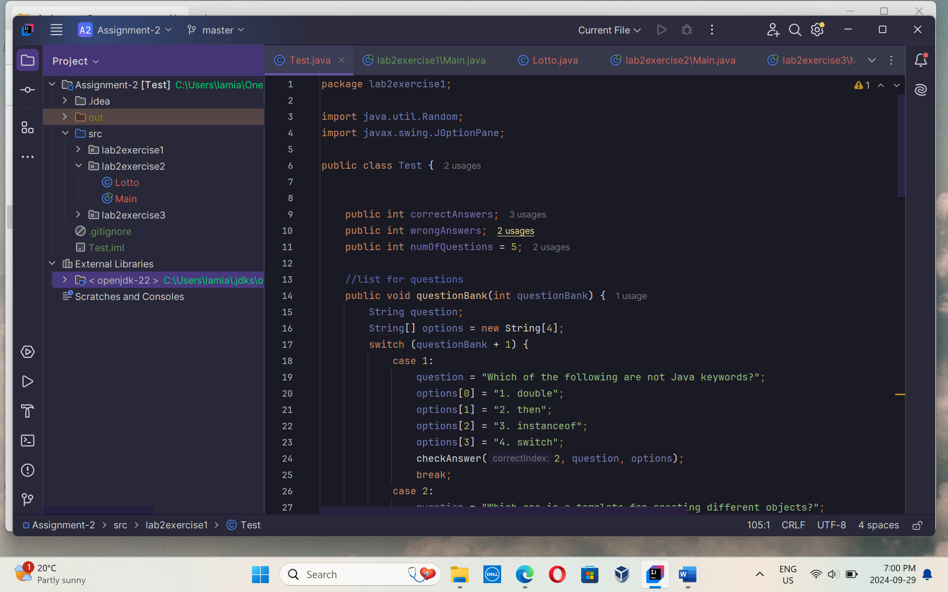

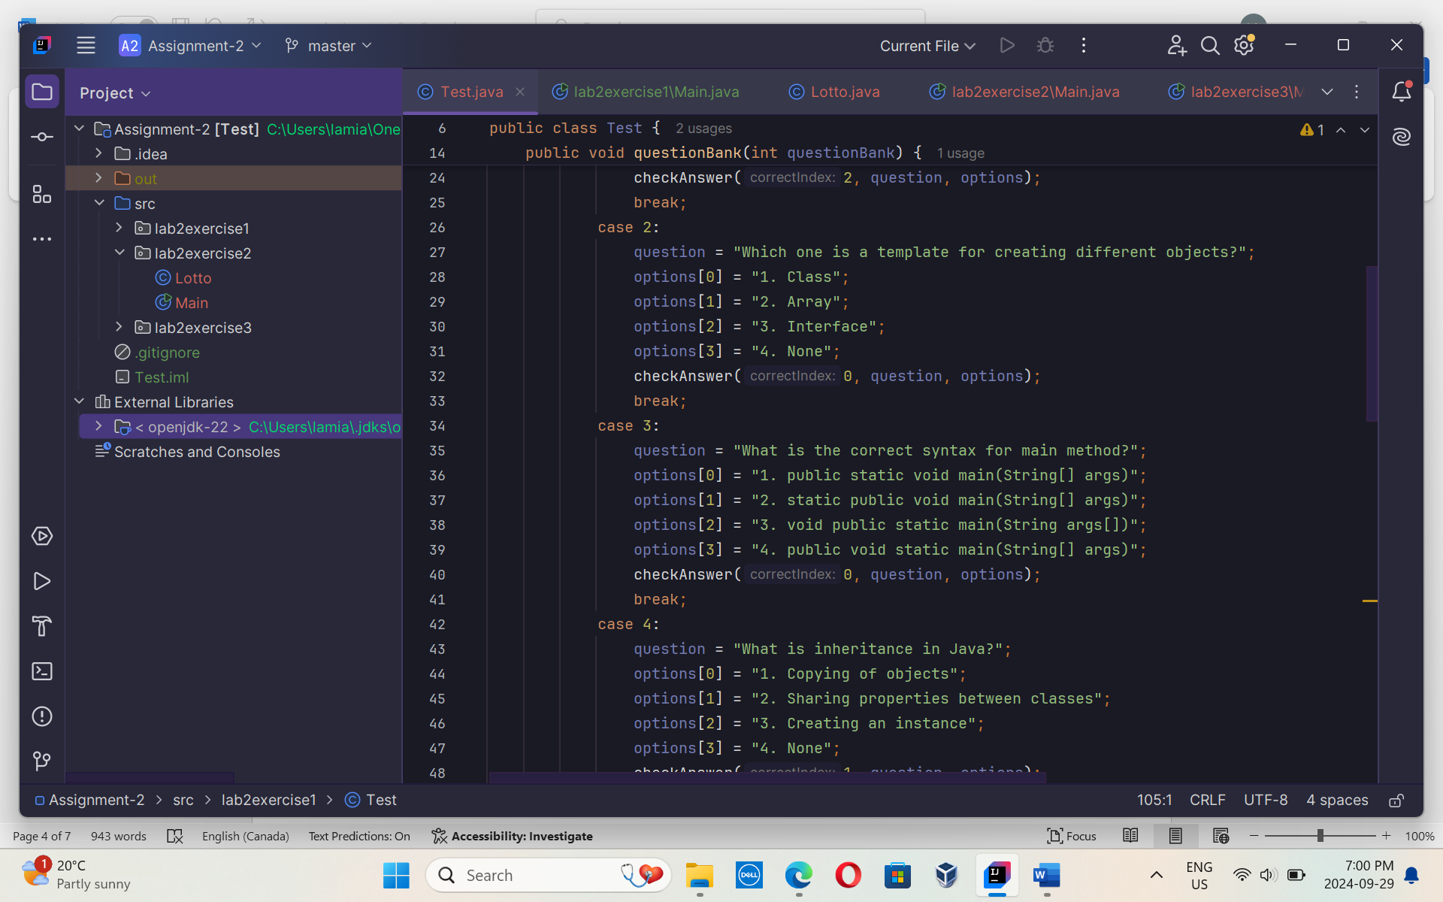

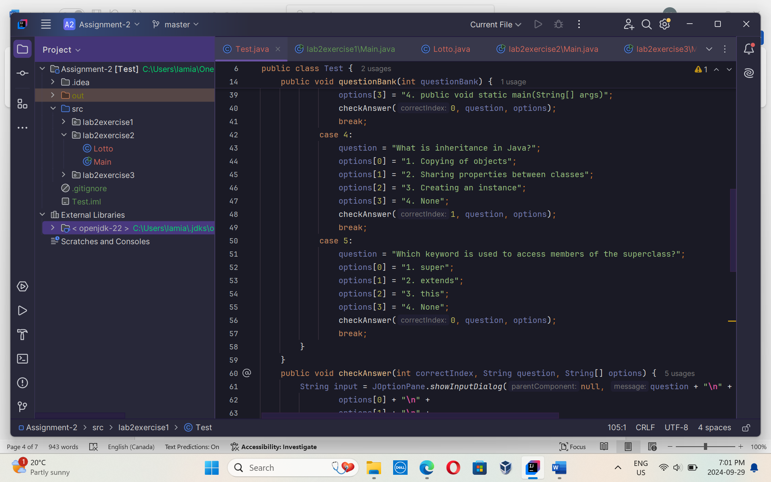

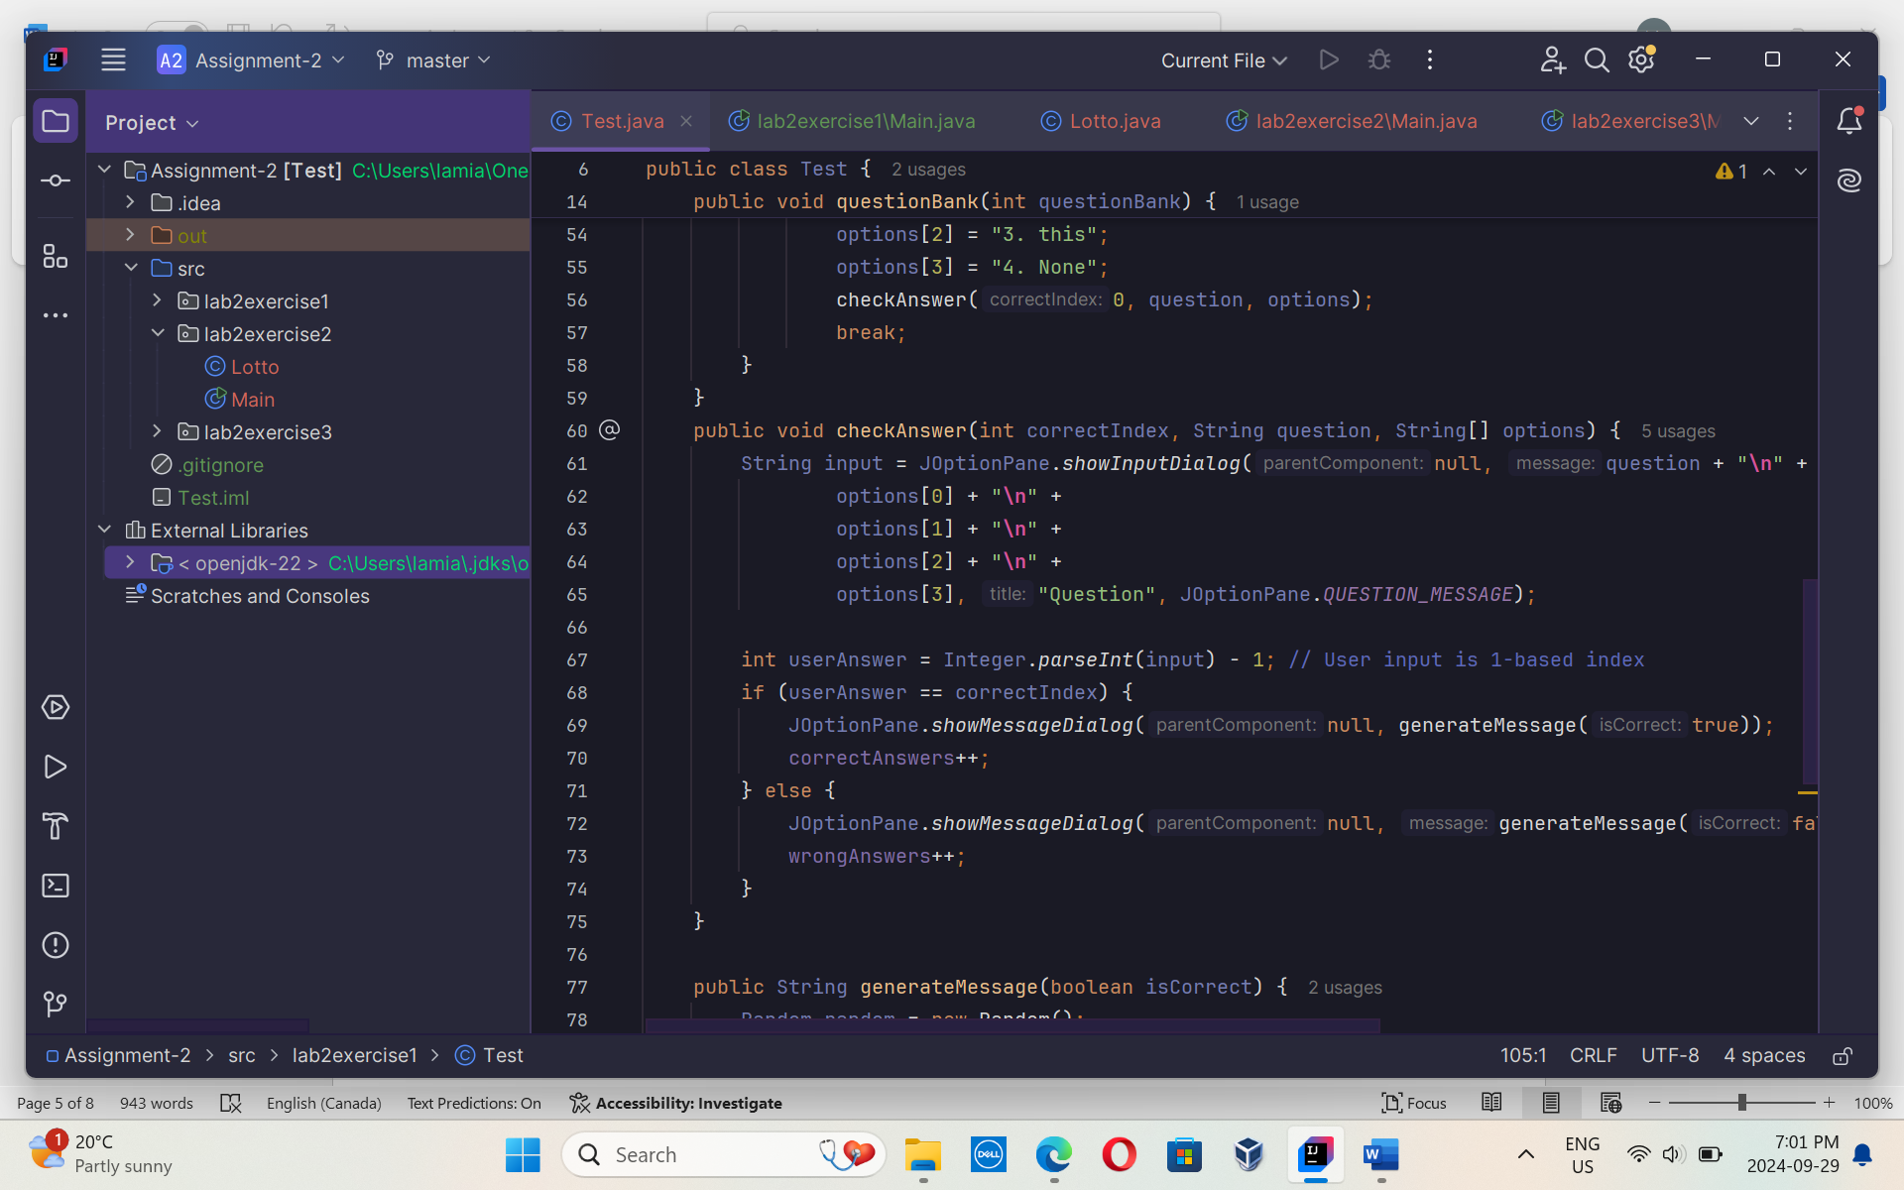

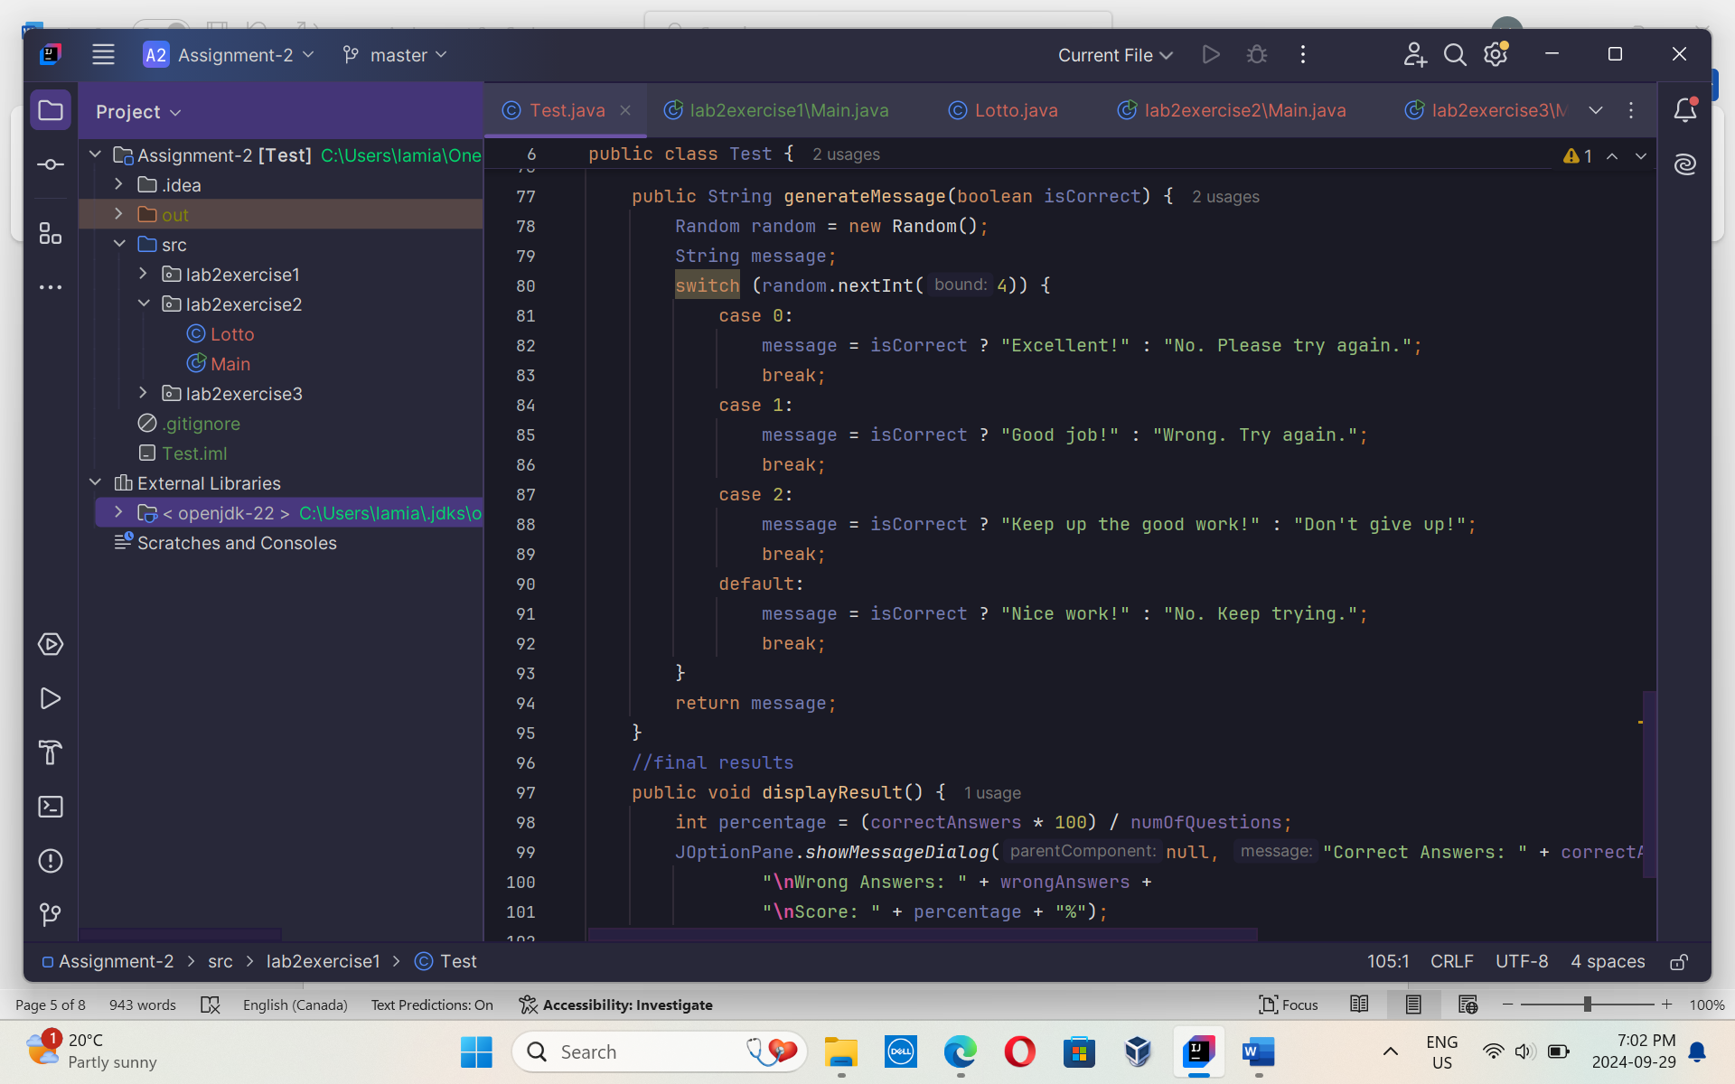

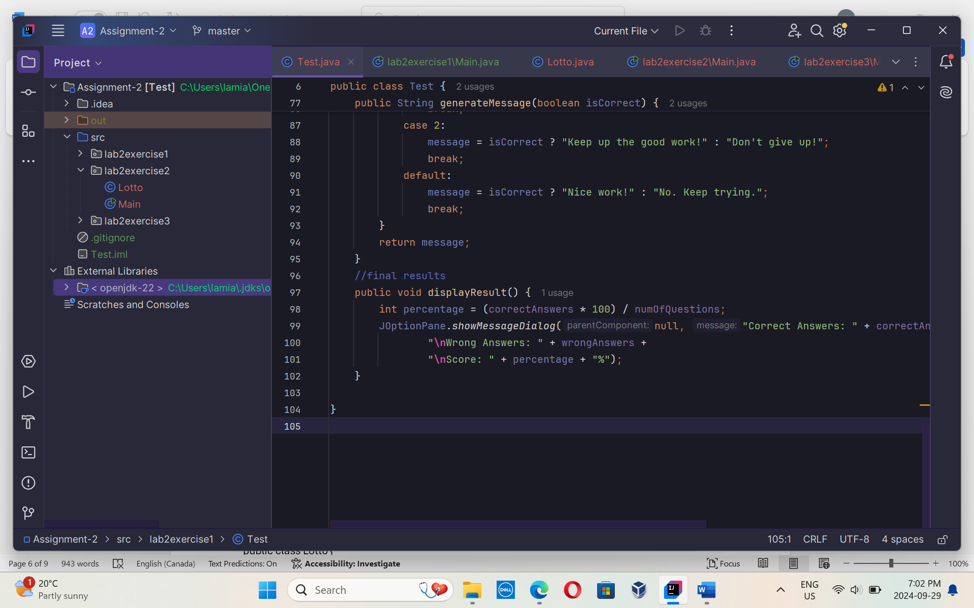

**Output:**

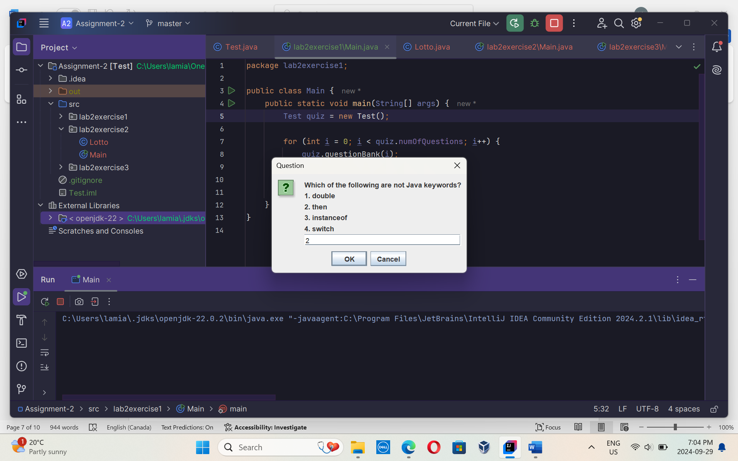

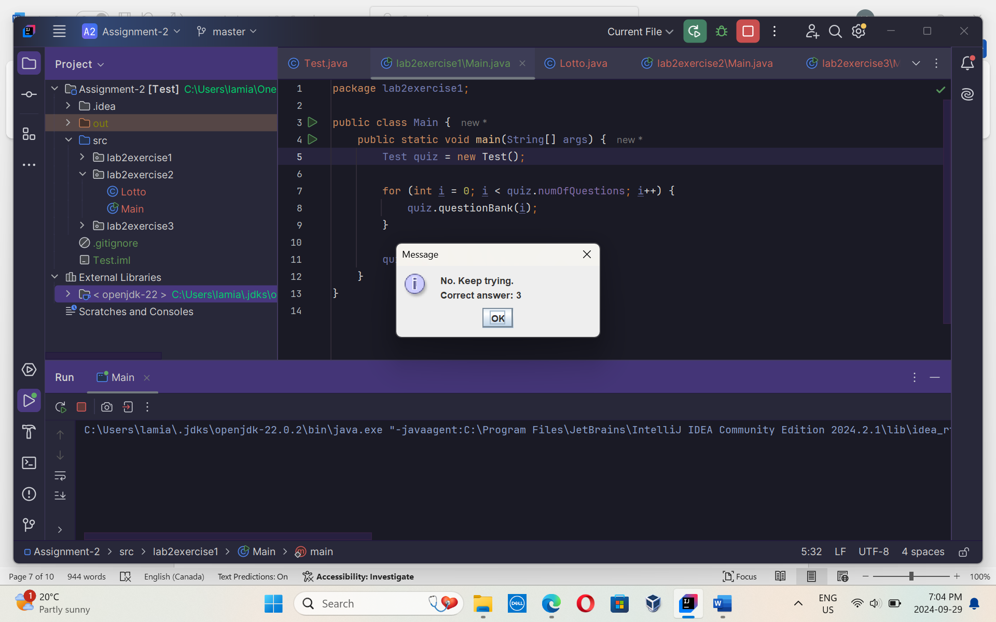

**Lab2Exercise1:**

Lotto class :

package lab2exercise2;  
  
import java.util.Random;  
  
public class Lotto {  
 private int[] generatedArray; // stores int values generated by the computer  
  
 public Lotto() {  
 Random random = new Random();  
 generatedArray = new int[3]; // array to hold 3 random numbers  
  
 // generates random numbers from 1 to 9  
 generatedArray[0] = random.nextInt(9) + 1;  
 generatedArray[1] = random.nextInt(9) + 1;  
 generatedArray[2] = random.nextInt(9) + 1;  
 }  
  
 // getter to return the array generated by the computer  
 public int[] getGeneratedArray() {  
 return generatedArray;  
 }  
  
 // method to calculate and return the sum of the lotto numbers  
 public int getLottoSum() {  
 return generatedArray[0] + generatedArray[1] + generatedArray[2];  
 }  
}

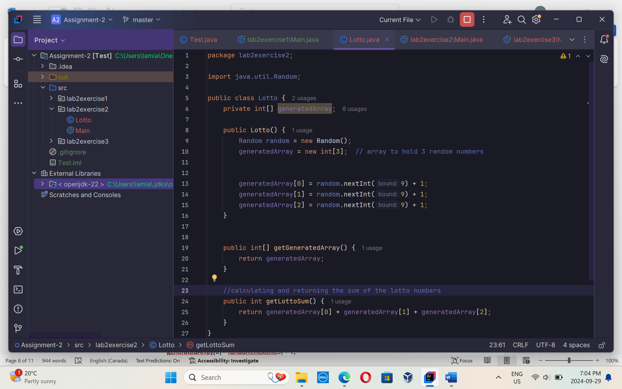

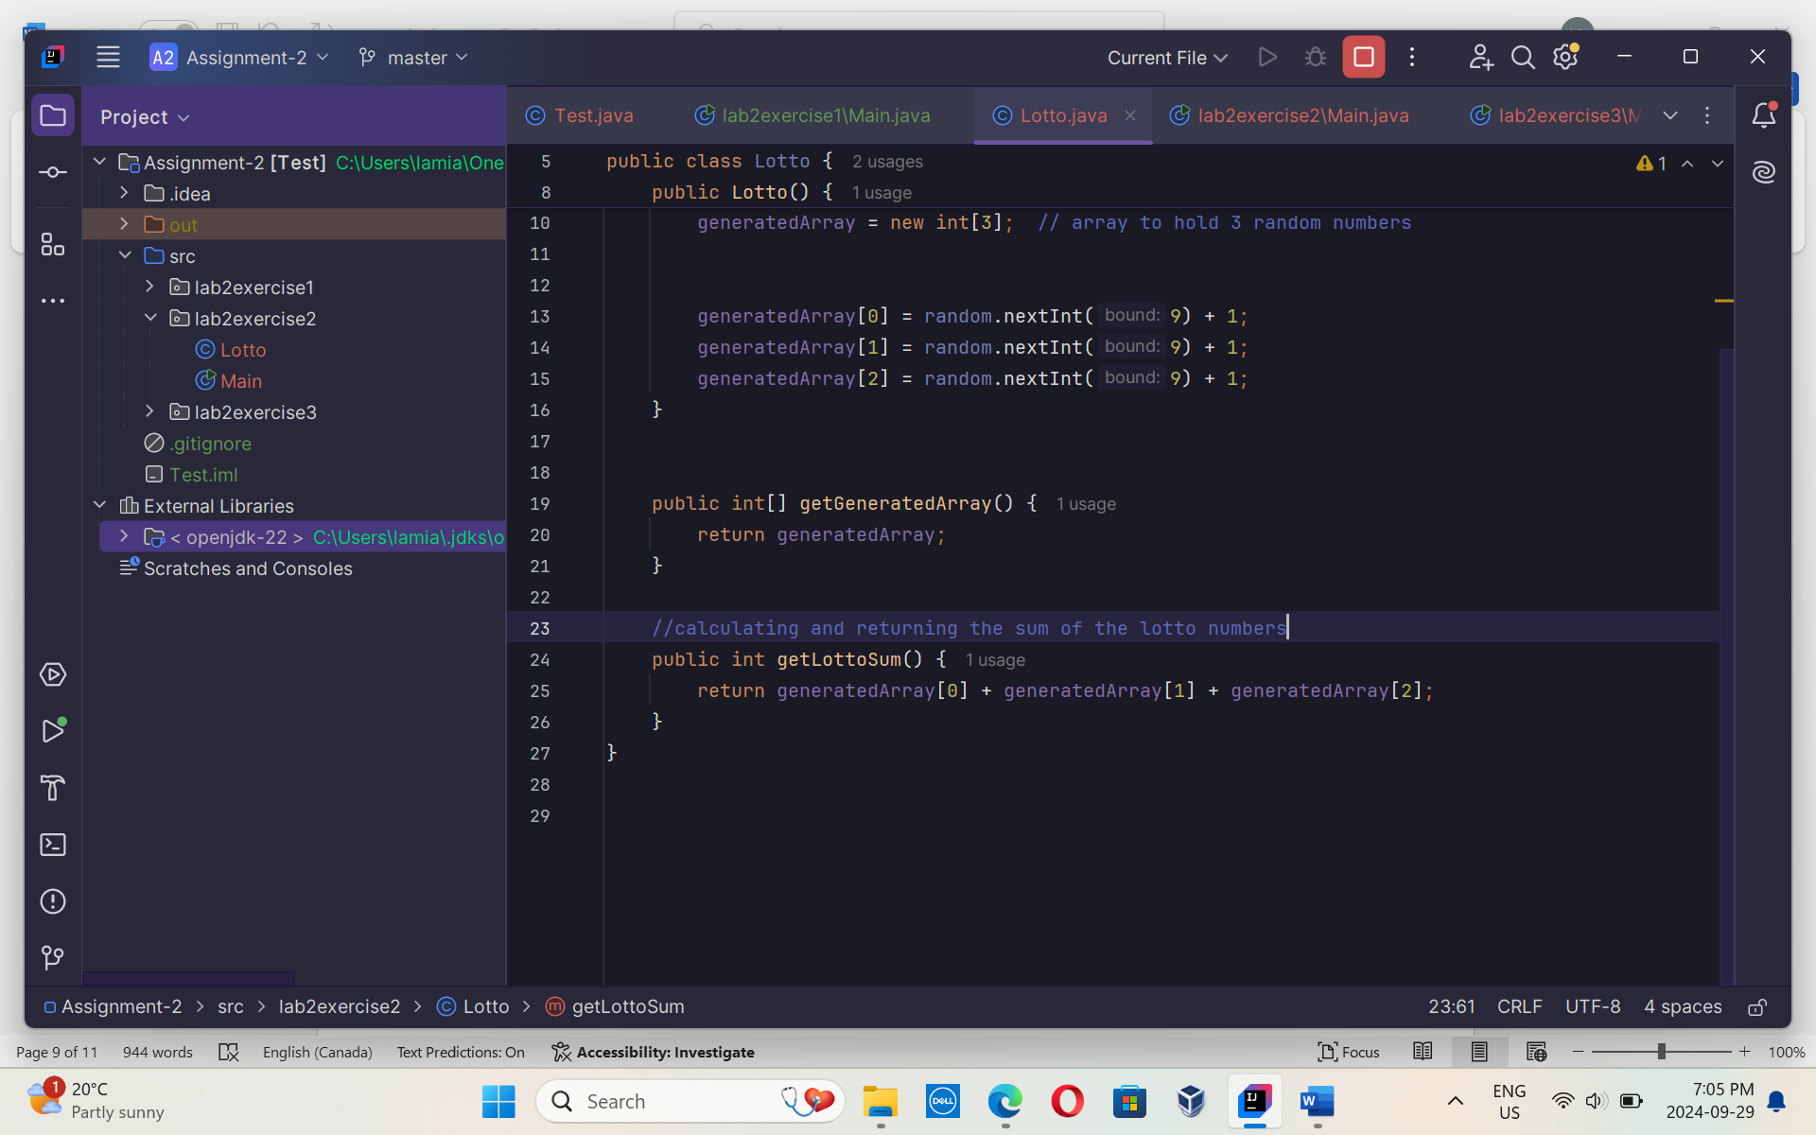

Main class:

package lab2exercise2;  
  
  
import javax.swing.JOptionPane;  
  
public class Main {  
 public static void main(String[] args) {  
 // Get the user's chosen number  
 String userInput = JOptionPane.*showInputDialog*("Choose a number between 3 and 27:");  
 int userNumber = Integer.*parseInt*(userInput); // Parse user input to an integer  
  
 int attempts = 0;  
 boolean userWins = false; // To track if user wins  
  
 // Allow the user to play up to 5 times  
 while (attempts < 5) {  
 Lotto lotto = new Lotto(); // Create a new Lotto object  
 int[] numbers = lotto.getGeneratedArray(); // Get the array of random numbers  
 int lottoSum = lotto.getLottoSum(); // Calculate the sum of lotto numbers  
  
 // Display the numbers and their sum to the user  
 String message = "Lotto numbers: " + numbers[0] + ", " + numbers[1] + ", " + numbers[2]  
 + "**\n**Lotto sum: " + lottoSum;  
 JOptionPane.*showMessageDialog*(null, message);  
  
 // Check if the sum matches the user's chosen number  
 if (userNumber == lottoSum) {  
 JOptionPane.*showMessageDialog*(null, "Congratulations! You've won!");  
 userWins = true; // User wins, so set this to true  
 break; // Exit the loop since the user won  
 } else {  
 JOptionPane.*showMessageDialog*(null, "Sorry, that's not the correct sum. Try again.");  
 }  
  
 attempts++; // Increment attempts  
  
 // If the user has had 5 tries and still hasn't won  
 if (attempts == 5) {  
 JOptionPane.*showMessageDialog*(null, "Sorry, you've used all your attempts. The computer wins!");  
 }  
 }  
 }  
}

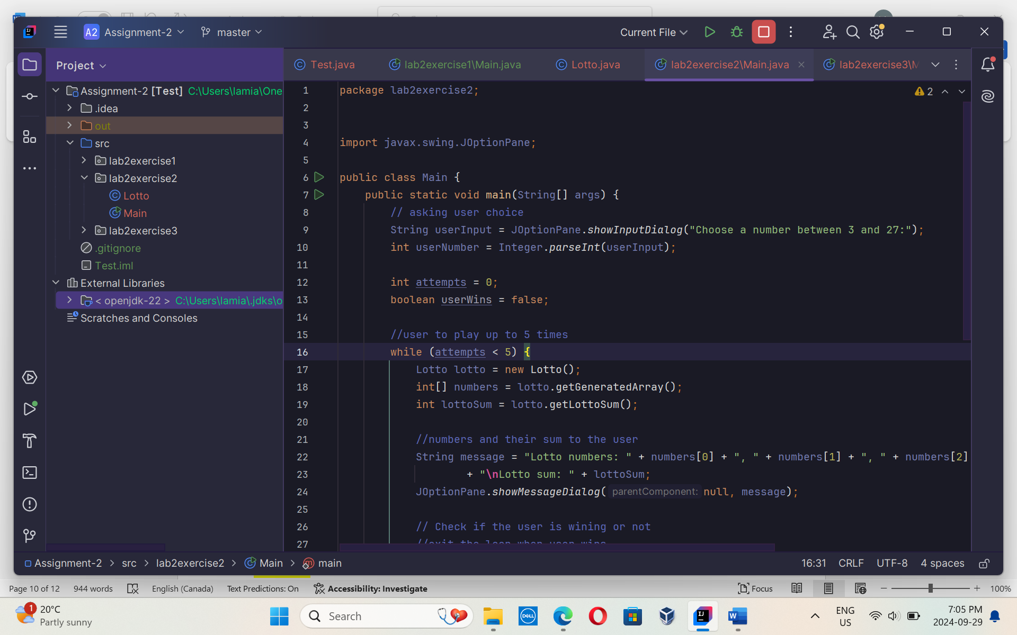

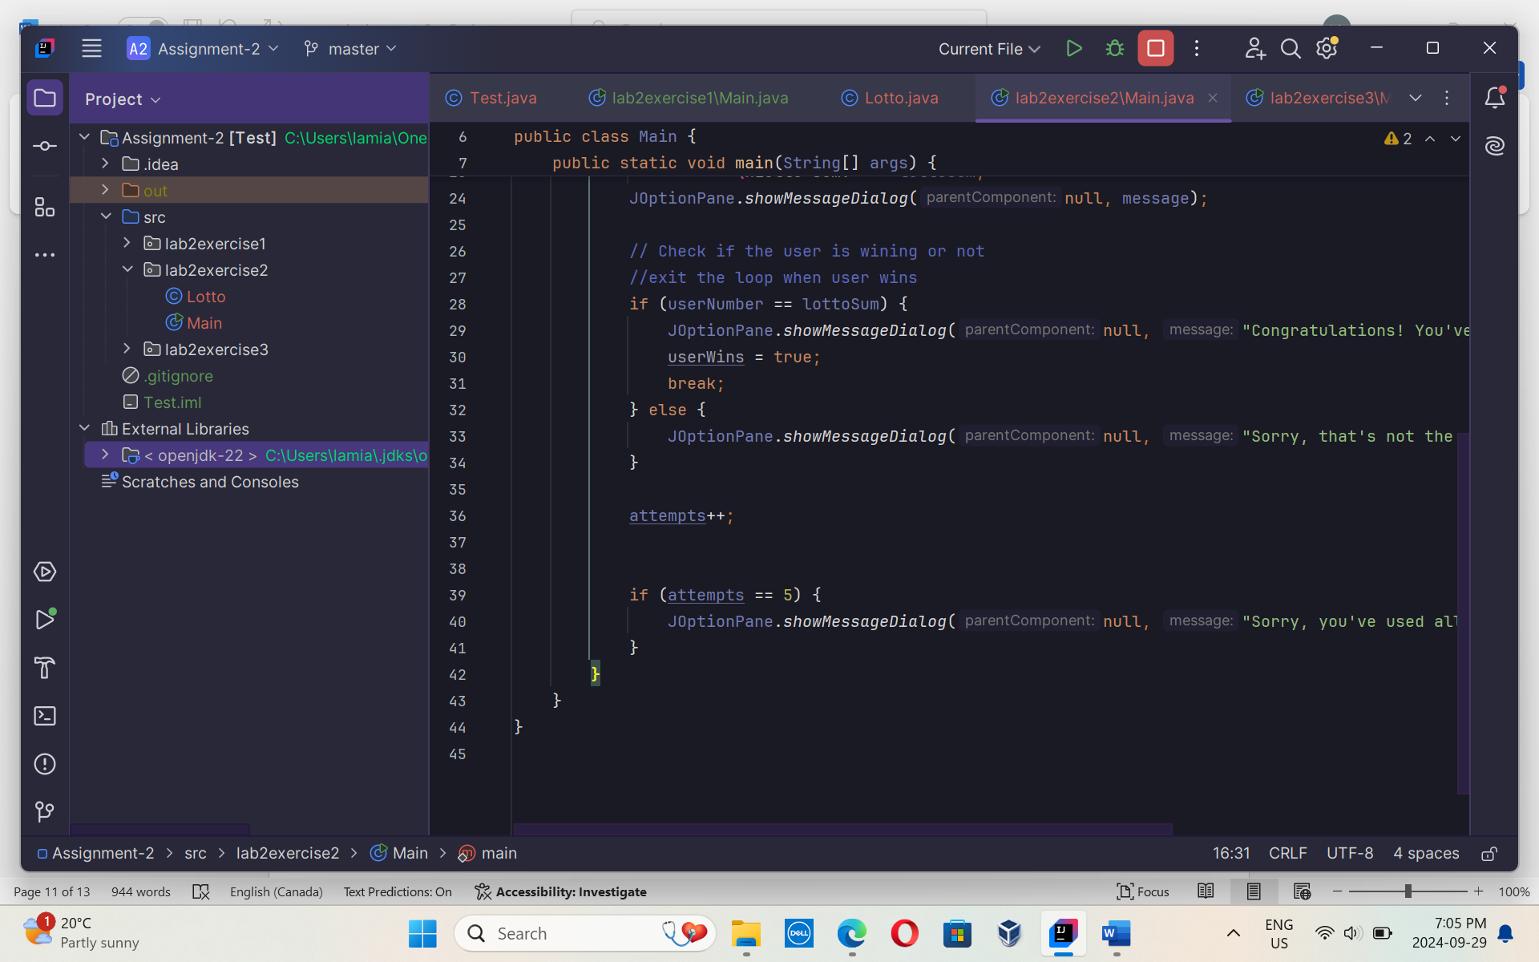

**Output:**

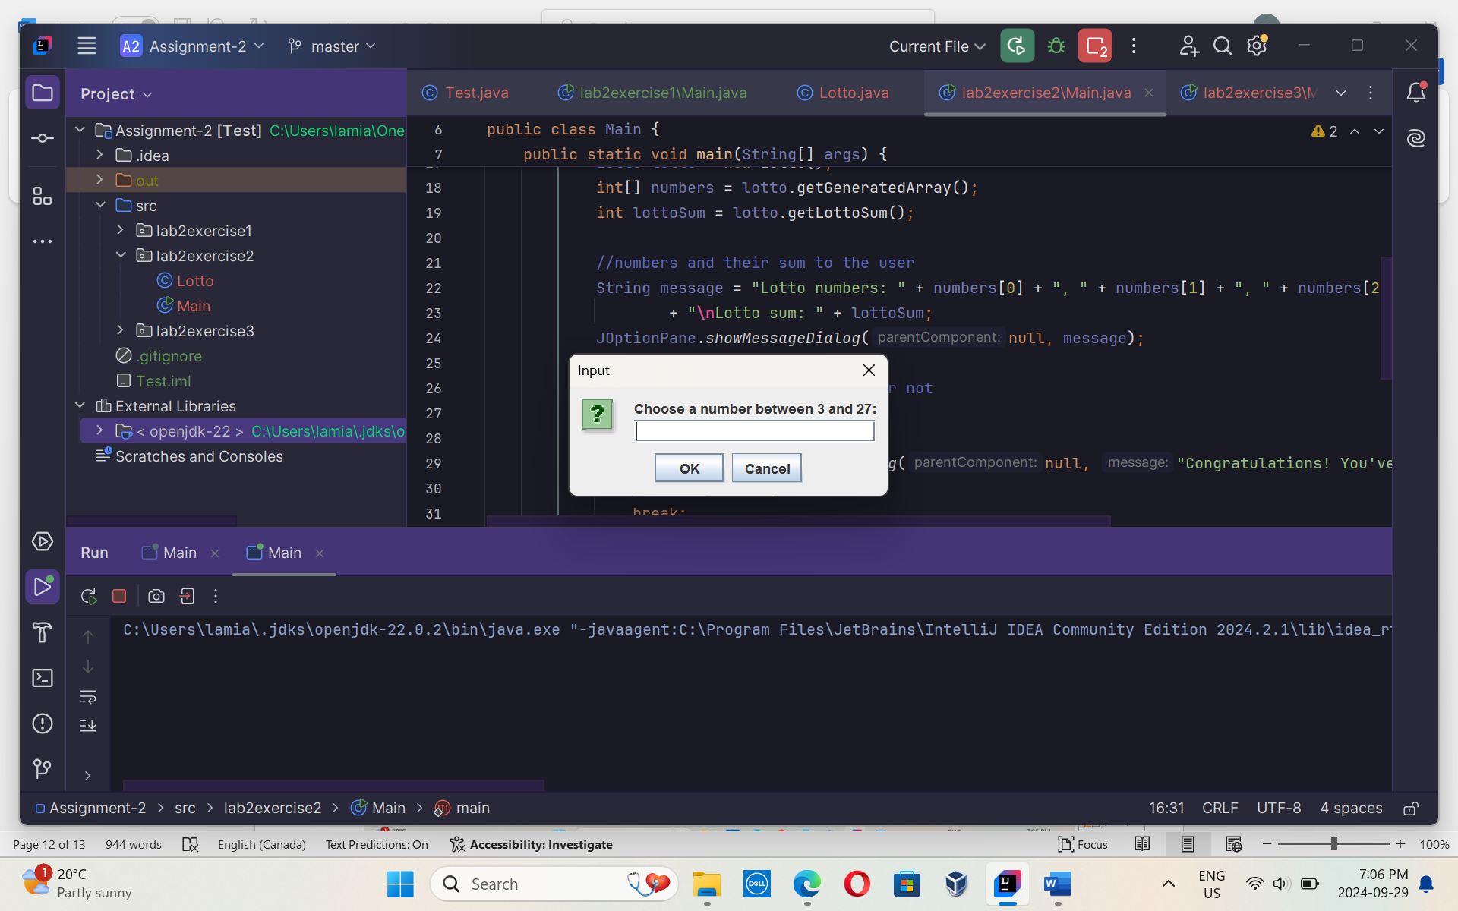

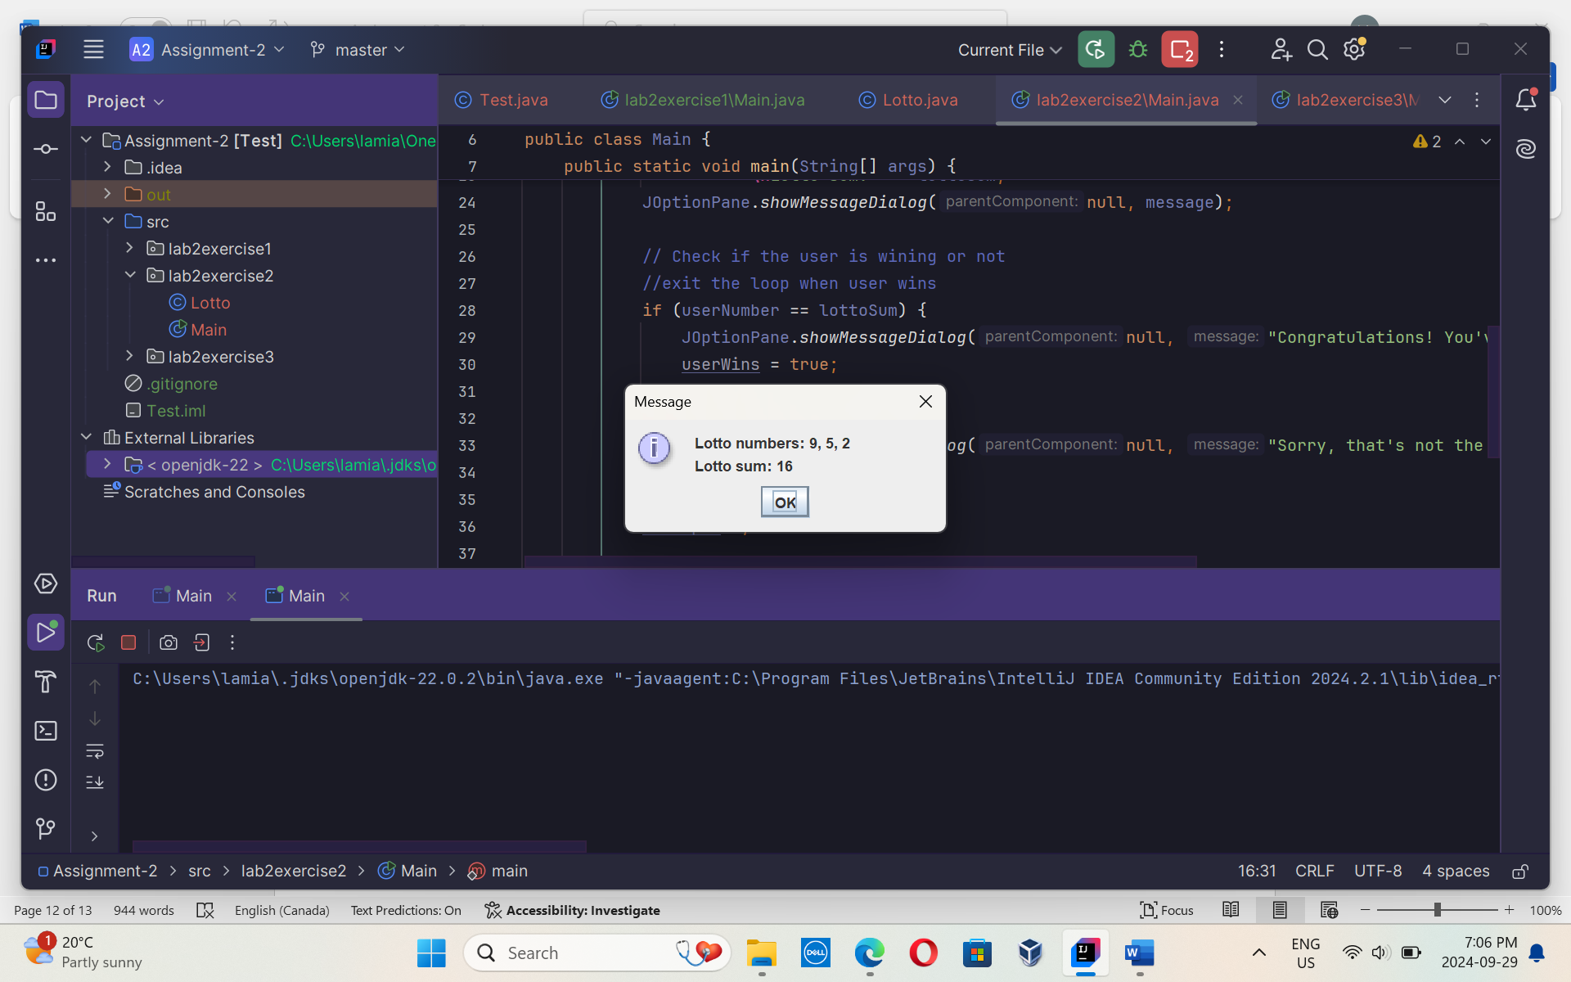

**Lab2Exercise1:**

Main class :

package lab2exercise3;  
public class Main {  
 public static void main(String[] args) {  
 // Calling the multiply method with two integers  
 int result1 = Multiplication.multiply(5, 7);  
 System.out.println("Multiplication of 5 and 7 (int): " + result1);  
  
 // Calling the multiply method with two doubles  
 double result2 = Multiplication.multiply(5.5, 3.2);  
 System.out.println("Multiplication of 5.5 and 3.2 (double): " + result2);  
  
 // Calling the multiply method with three integers  
 int result3 = Multiplication.multiply(2, 3, 4);  
 System.out.println("Multiplication of 2, 3, and 4 (int): " + result3);  
 }  
}

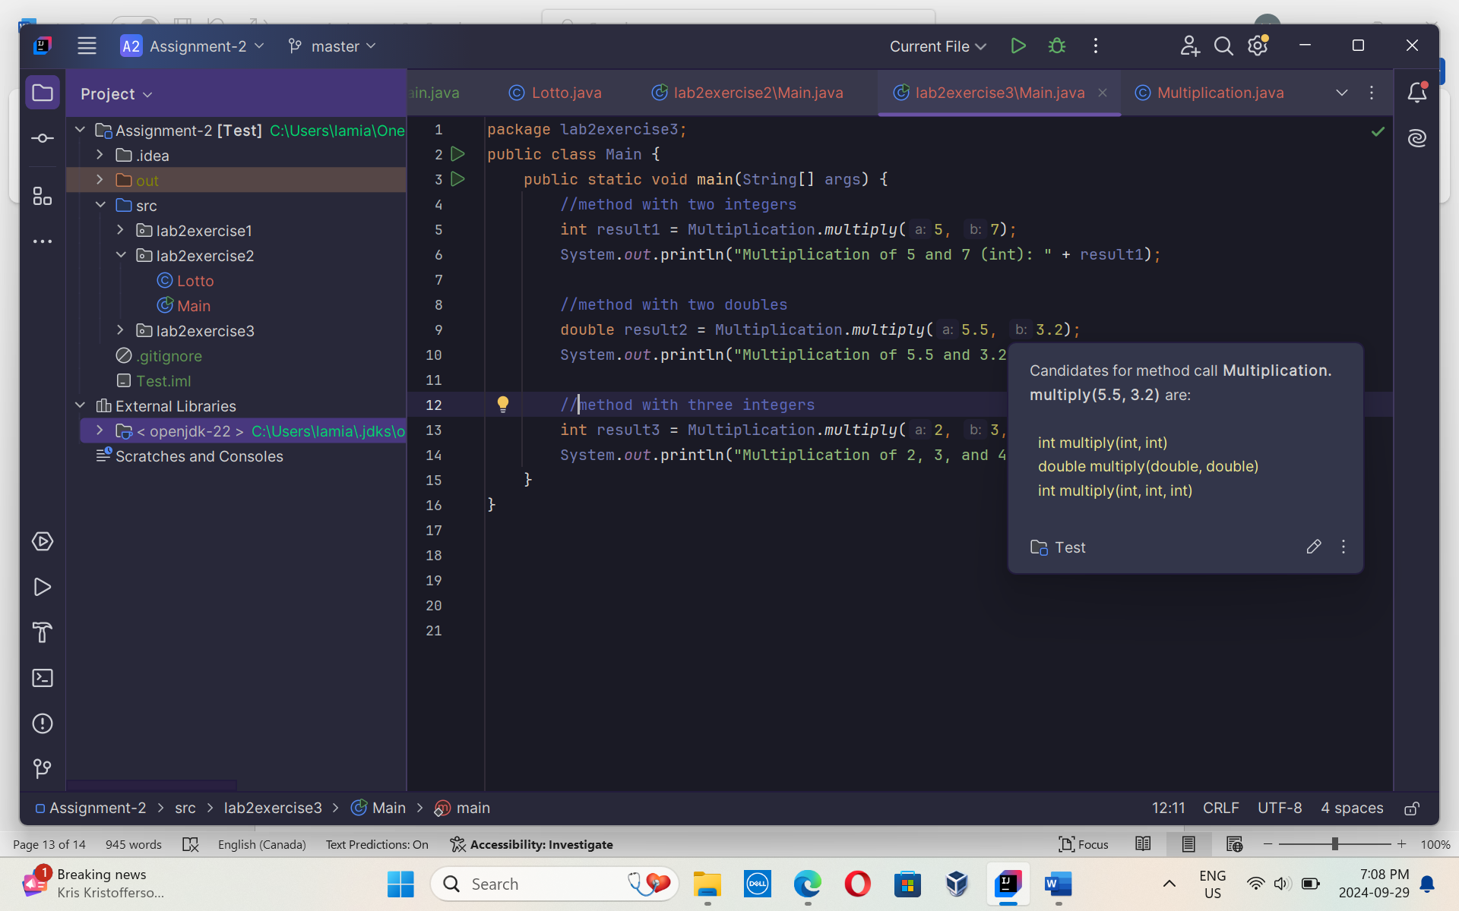

Multiplication class:

package lab2exercise3;  
  
public class Multiplication {  
  
 // Overloaded static method to multiply two integers  
 public static int multiply(int a, int b) {  
 return a * b;  
 }  
  
 // Overloaded static method to multiply two doubles  
 public static double multiply(double a, double b) {  
 return a * b;  
 }  
  
 // Overloaded static method to multiply three integers  
 public static int multiply(int a, int b, int c) {  
 return a * b * c;  
 }  
}

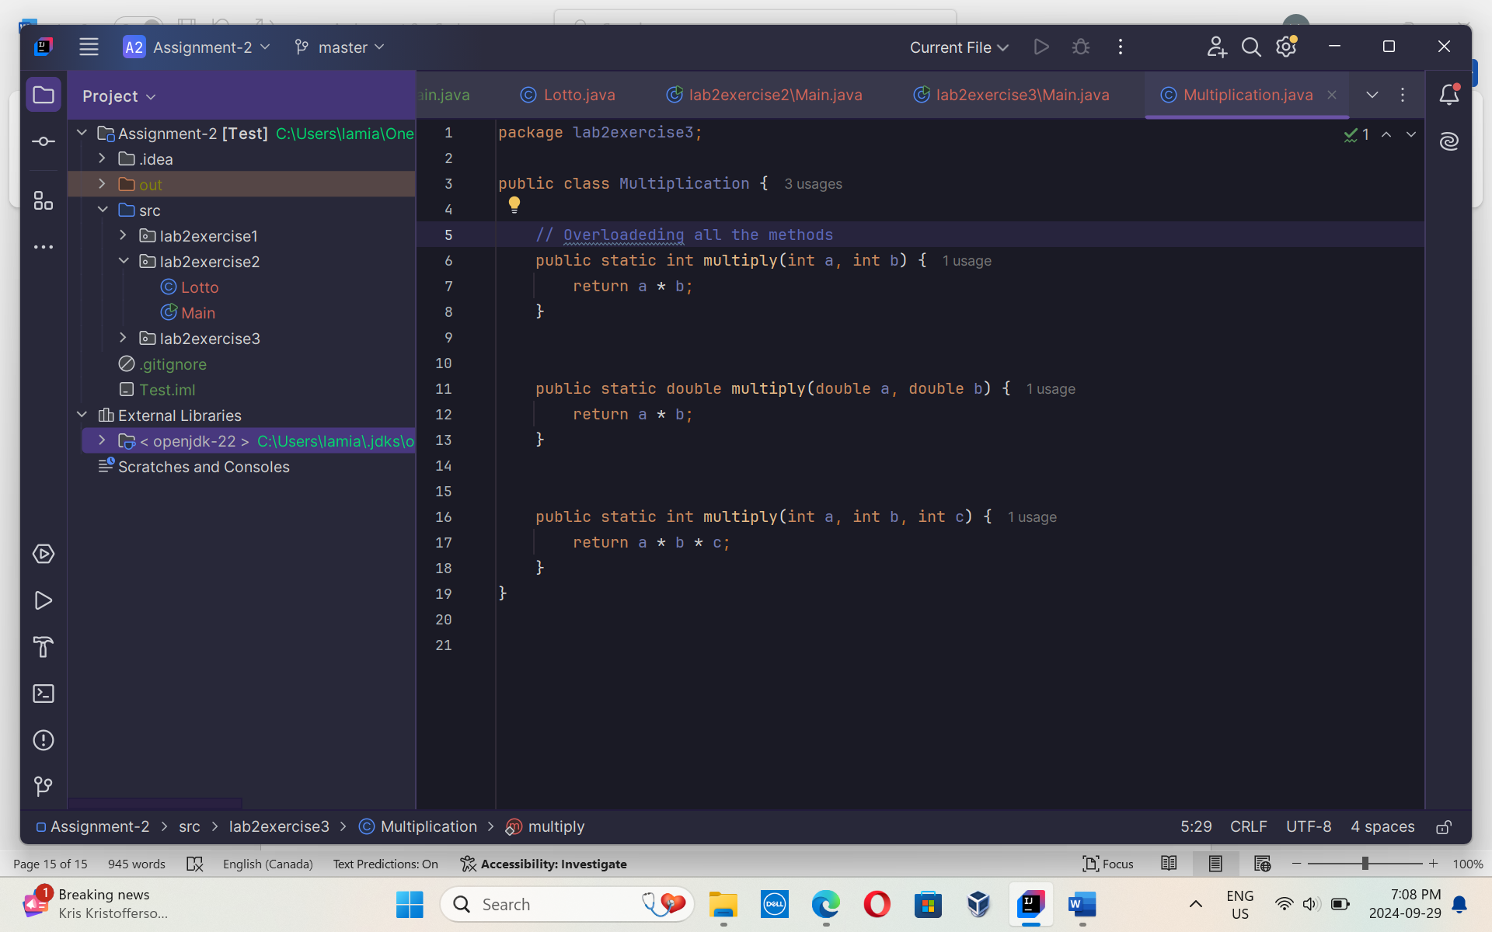

**Output:**

